Other Options

Feed the Homeless for Saturday, June 10, 2023

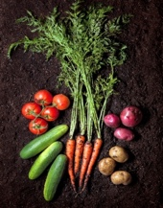
Fresh Veggies and Dip

Cookies

- Drop off food in the St Albert’s parking lot between 9 and 10 AM – please drive up to the breezeway.

- NEW Drop off instructions:
- No early drop offs – if you can’t make the drop off time, take your food directly to the NEW St Vincent DePaul kitchen behind the Job Center at 1111 S. Edwin C. Moses Blvd in Dayton anytime
- Please put the food in the trunk or back of your vehicle
- Please stay in your vehicle, we will take it out

- Please bring one or more of the following:

  - 2 lbs of fresh veggies (broccoli, carrots, et) and 1 bottle of ranch dressing.

  - Three dozen cookies or brownies

Thanks!

